Ecocycle documentation
Development software 2A Group Project

Project Overview
Introduction
Ecocyle is a web-based application designed to support recycling buy-back centres and informal waste pickers in South Africa. The platform aims to improve environmental sustainability by creating a more organized and transparent recycling system. It provides a digital solution for recording recyclable material transactions, managing waste picker information, and tracking income generated through recycling activities.

The system also seeks to recognize and support the important role played by informal waste pickers in reducing environmental pollution and promoting recycling within communities.
2.Problem statement
Environmental sustainability remains a significant issue due to the increasing in pollution, waste accumulation, and the poor waste management practices. Informal recycling in South Africa plays a unique role in reducing environmental damage through the efforts of informal waste pickers, who sort through vast amounts of waste in the streets and hazardous environments to collect recyclable materials that can be used to produce new materials and products.
Many recycling buy-back centres do not have structured systems to track recyclable materials, waste picker information, or financial transactions. As a result, waste pickers often experience unstable income, lack formal identification within the system, and face limited financial transparency.
Organisations such as recycling buy back centres purchase recyclable materials from waste pickers but maintain extraordinarily little documentation regarding the materials that are collected, who supplied them and the related financial transactions.
These challenges create the need for formalized record keeping, improved financial transparency, data driven insights within the informal recycling sector.

3.Business Requirements
- The system must allow buy-back centres employees to register waste pickers to personal information.
- The system must allow recycling buy-back centres to record recyclable material transactions.
- The system must calculate and record payments made to waste pickers.
- The system must provide transparency in recyclable material pricing.
- The system must generate income tracking for waste pickers.
- The system must display environmental statistics and recycling trends.
- The system must integrate Google Maps API to display recycling buy-back centre locations and activity.
- The system must securely store user and transaction data.
- The system must be accessible through desktop and mobile devices.
- The system must reward the highest contributors to support and encourage waste picker participation in recycling activities which is managed by employees.

4.User-Roles and Divisions
System Administrator (super admin): Monitor environmental data, view AI material trends, manage system-wide insights, and oversee platform functionality.
Administrator (Buyback Centre Manager): Responsible for overseeing recycling centre operations and monitoring system data. Manage recyclable material prices, monitor transactions, view income reports, and access environmental dashboards.
Buyback staff (Employee): Register waste pickers, record recyclable material transactions, update system records , manage reward tracking for waste pickers .
Additional Stakeholders:
Waste pickers are beneficiaries of the system whose information and transactions are managed by buy-back centre staff through the platform. This approach was chosen because many informal waste pickers may have limited access to smartphones, internet connectivity, or digital literacy, making direct interaction with the system difficult. The platform therefore allows recycling centre staff to manage and capture information on their behalf.
5.Use Case Diagram

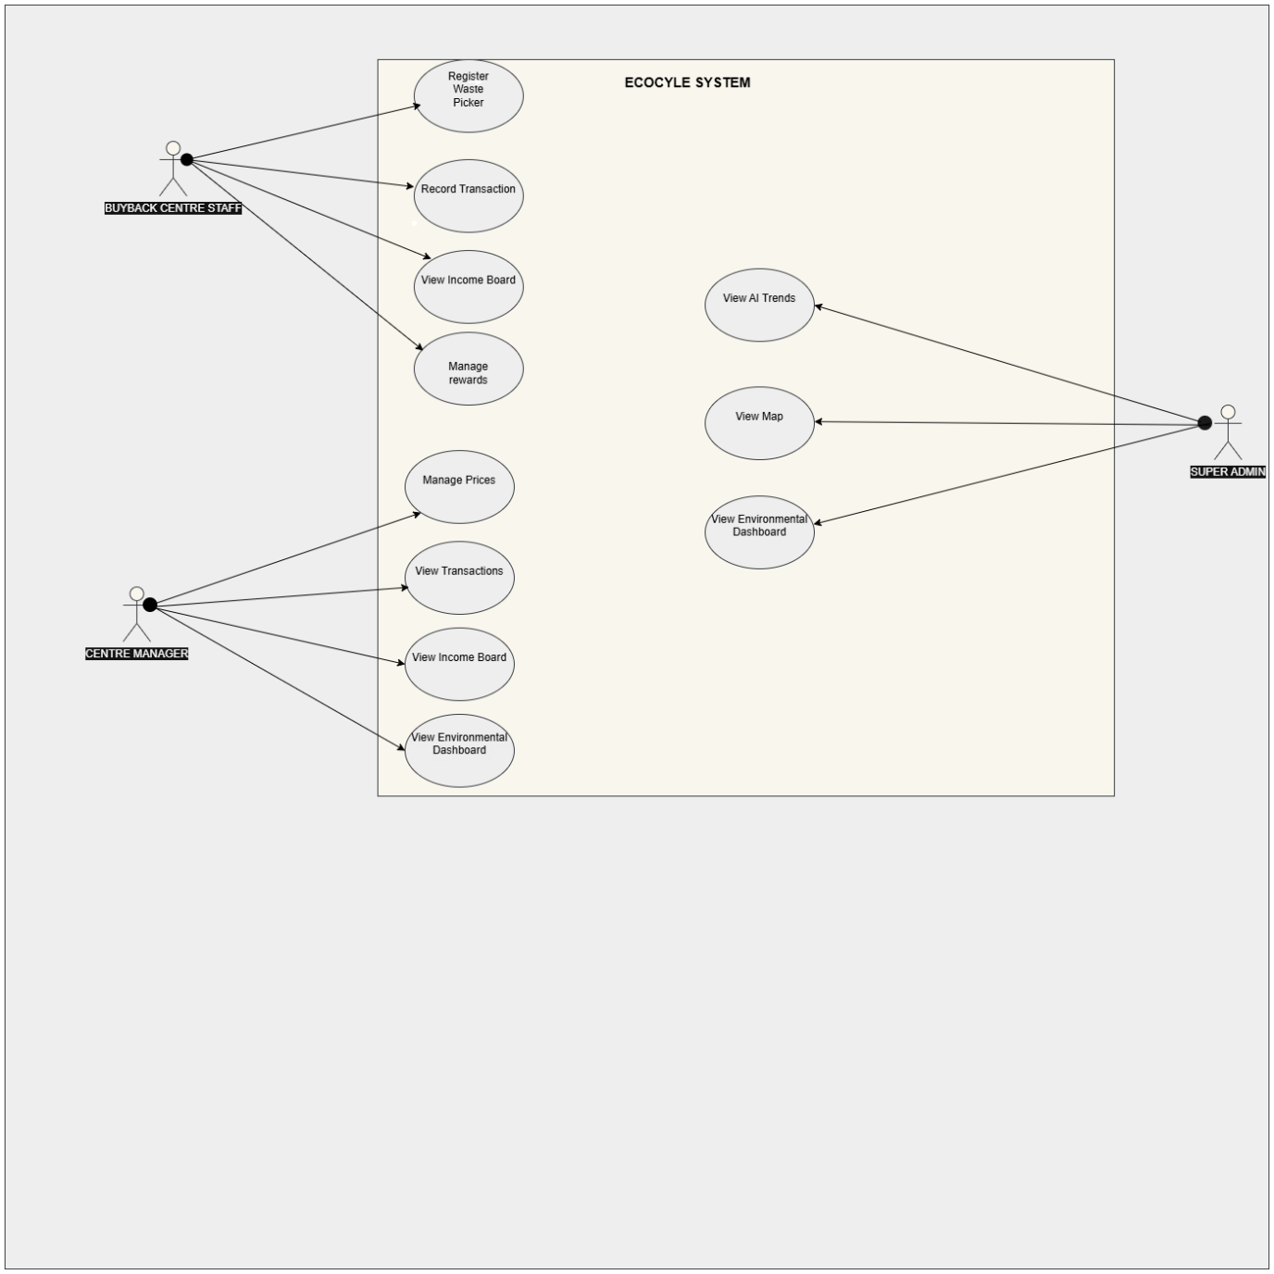
6.USE CASE DESCRIPTIONS

USE CASE Name | Register waste picker
ACTOR | Buyback centre employees
DESCRIPTION | It allows the buyback centre employees to register waste pickers and store their information in the system
PRE CONDITION | The employee must be logged in the system to do this
POST CONDITION | The waste picker information is stored in the system in the database

USE CASE Name | Record transaction
ACTOR | Buyback centre employees
DESCRIPTION | It allows the buyback employees to record recyclable materials that are brought by waste pickers and calculates payments
PRE CONDITION | The waste picker must already be registered in the system
POST CONDITION | Transaction information are saved in the system successfully

USE CASE Name | Manage Prices
ACTOR | Admin (centre manager)
DESCRIPTION | It allows the admin to set and update prices within the system
PRE CONDITION | The manager must be logged in the system to do this
POST CONDITION | The updates are saved and applied to future transactions

USE CASE Name | View Environmental Dashboard
ACTOR | Admin(centre manager)
DESCRIPTION | It allows the Admin to monitor environmental statistics and recycling data
PRE CONDITION | The Admin must be logged in the system to do this
POST CONDITION | Environmental statistics are displayed successfully

SYSTEM REQUIREMENTS
- Functional Requirements
- System shall allow waste pickers to register at a buy-back centre (name, ID number, phone number).
- System shall enable buy-back centre staff to record each recyclable material transaction (picker, material type, weight/quantity, price, total paid).
- System shall maintain a price list for recyclable materials (per kg or per unit).
- System shall calculate and display an income board for each waste picker (daily, monthly, total).
- System shall generate an environmental dashboard with monthly material volume leaders.
- System shall provide an AI-based material trend tracker showing which materials are increasing in volume.
- System shall integrate a map API to display buy-back centre locations.
- System shall support three roles: User (buy-back centre staff), Admin, Super Admin.
- Non-Functional Requirements
- AI trend predictions refresh daily (off-peak hours).
- System must handle up to 50 concurrent buy-back centre users.
- Page load time must be less than 5 seconds.
- All financial transactions must be recorded/logged.

Overview of functions and Non-functions
Functions:
- Register waste pickers
- Record transactions
- Update material prices
- View earnings by picker
- View monthly material leaders on the income dashboard
- View trending materials on AI trend tracker
- Map API shows centres with statistics
- Three roles allow access
Non-Functions:
- User/Admin can register waste pickers
- Only Admin/super Admin can edit prices
- System handles 50+ buy-back centres concurrently
- The system refreshes daily
- There is strict access control for each user
- The app is responsive for all mobile users

User Interface (UI)
Role-Based Views
Waste Picker (View Only – via kiosk or staff)
- Income board (chart + table)
- Transaction history
User (Buy-Back Centre Staff)
- Dashboard: Quick transaction form
- Register new picker
- View price list (read-only, unless Admin)
- Income board for any picker
- Environmental dashboard
- Map of centres
Admin (Manages 1 or more centres)
- All User features +
- Edit material prices
- View all transactions across centres they manage
Super Admin
- All Admin features +
- Add/edit buy-back centres
- Manage user accounts (create/disable)
- View full audit log(recorded transactions)

